**Lock&Key**

Projekat iz Web programiranja 1

<https://lthechubbyl.github.io/lock_key/>

Miloš Čubrak 35/21

Internet Tehnologije

Table of Contents

1 Uvod 2

1.1 Korišćeni programski jezici 2

1.2 Opis funkcionalnosti 2

1.3 Template 2

2 Organizacija 3

2.1 Organizaciona šema 3

2.2 Mapa sajta 3

2.3 Slike stranica i opisi funkcionalnosti 4

3 Kodovi 10

3.1 HTML 10

3.1.1 index.html 10

3.1.2 contact.html 20

3.2 CSS 28

3.2.1 my-style.css 28

3.2.2 style.css - (template) 29

3.3 JavaScript 40

3.3.1 main.js 40

3.3.2 custom-jquery.js 52

3.3.3 template-main.js - (template) 53

LOCK&KEY

# Uvod

## Korišćeni programski jezici

* HTML5, CSS3, Bootstrap 5.2, JavaScript, JQuery, Owl Carousel, Wow.js
* Visual Studio Code

## Opis funkcionalnosti

* Dinamicko kreiranje navigacije
* Slider pomocu Owl Carousel
* Filtriranje elemenata kroz ddl
* Filtriranje elementa preko tastera
* Ispisivanje dodatnog tekstualnog sadrzaja preko dugmeta
* Elementi koji se ponavljaju su kreirani putem javascripta
* Dinamicko kreiranje footer-a
* Validacija forme, koriscenje regularnih izraza i ispisivanje gresaka

## Template

* <https://htmlcodex.com/real-estate-html-template-free/>

# Organizacija

## Organizaciona šema

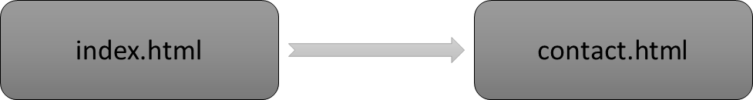

## Mapa sajta

<?xml version="1.0" encoding="UTF-8"?>

<urlset xmlms="http://www.sitemaps.org/schemas/sitemap/0.9">

    <url>

        <loc>https://lthechubbyl.github.io/lock_key/index.html</loc>

        <lastmod>2022-12-15</lastmod>

        <changefreq>daily</changefreq>

        <priority>1.0</priority>

    </url>

    <url>

        <loc>https://lthechubbyl.github.io/lock_key/contact.html</loc>

        <lastmod>2022-12-15</lastmod>

        <changefreq>weekly</changefreq>

        <priority>0.8</priority>

    </url>

</urlset>

## Slike stranica i opisi funkcionalnosti

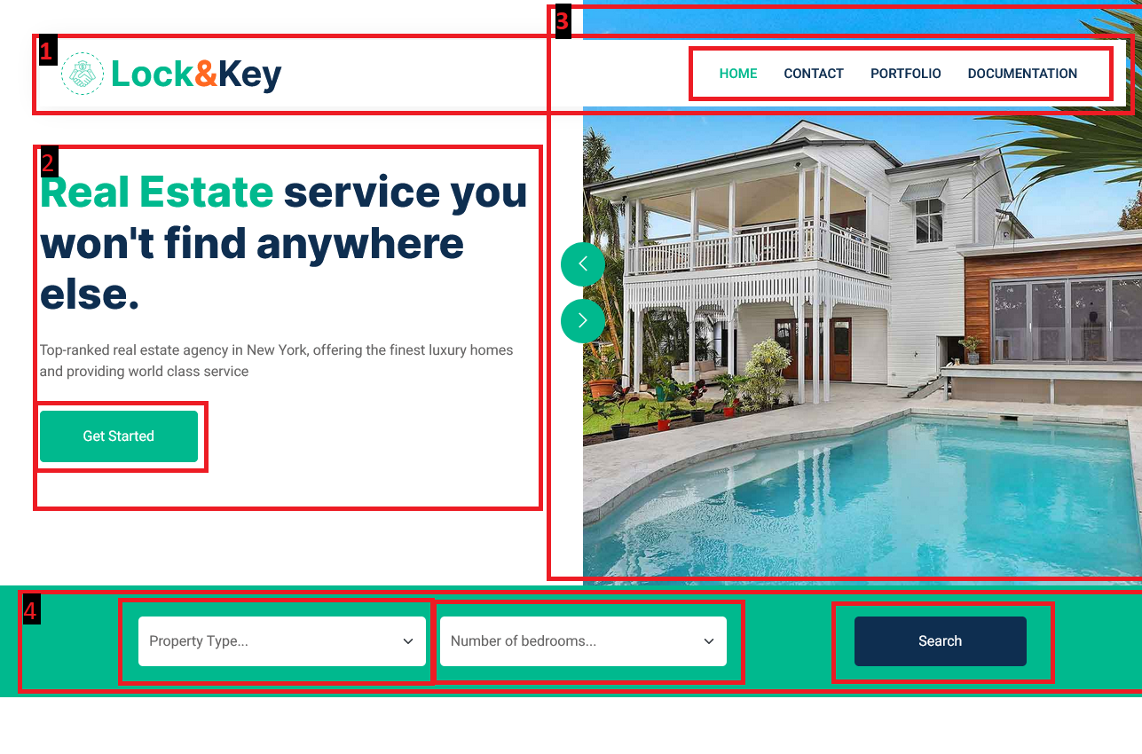

**1.**

* Dinamicko kreiranje linkova unutar navigacionog menija
* Dodeljivanje active klase ispitivanjem title taga

**2.**

* Taster “Get Started” vodi do sekcije “Property Listing”

**3.**

* Slider kreiran pomocu Owl Carousel

**4.**

* Omoguceno filtriranje pomocu “Property Type” DropDownList i “Number of bedrooms” DropDownList, obe liste su dinamicki kreirane
* Unutar “Property Type” DDL se bira tip objekta od ponudjenih “Appartment, Building, Home, Villa”
* Unutar “Number of bedrooms” DDL se bira broj soba od ponudjenih “3 bedroom/s, 6 bedroom/s”
* Klikom na taster “Search” se poziva funkcija koja filtira elemente u sledecoj sekciji “Property Listing” prema uputstvima bilo koje kombinacije odabira unutar obe liste

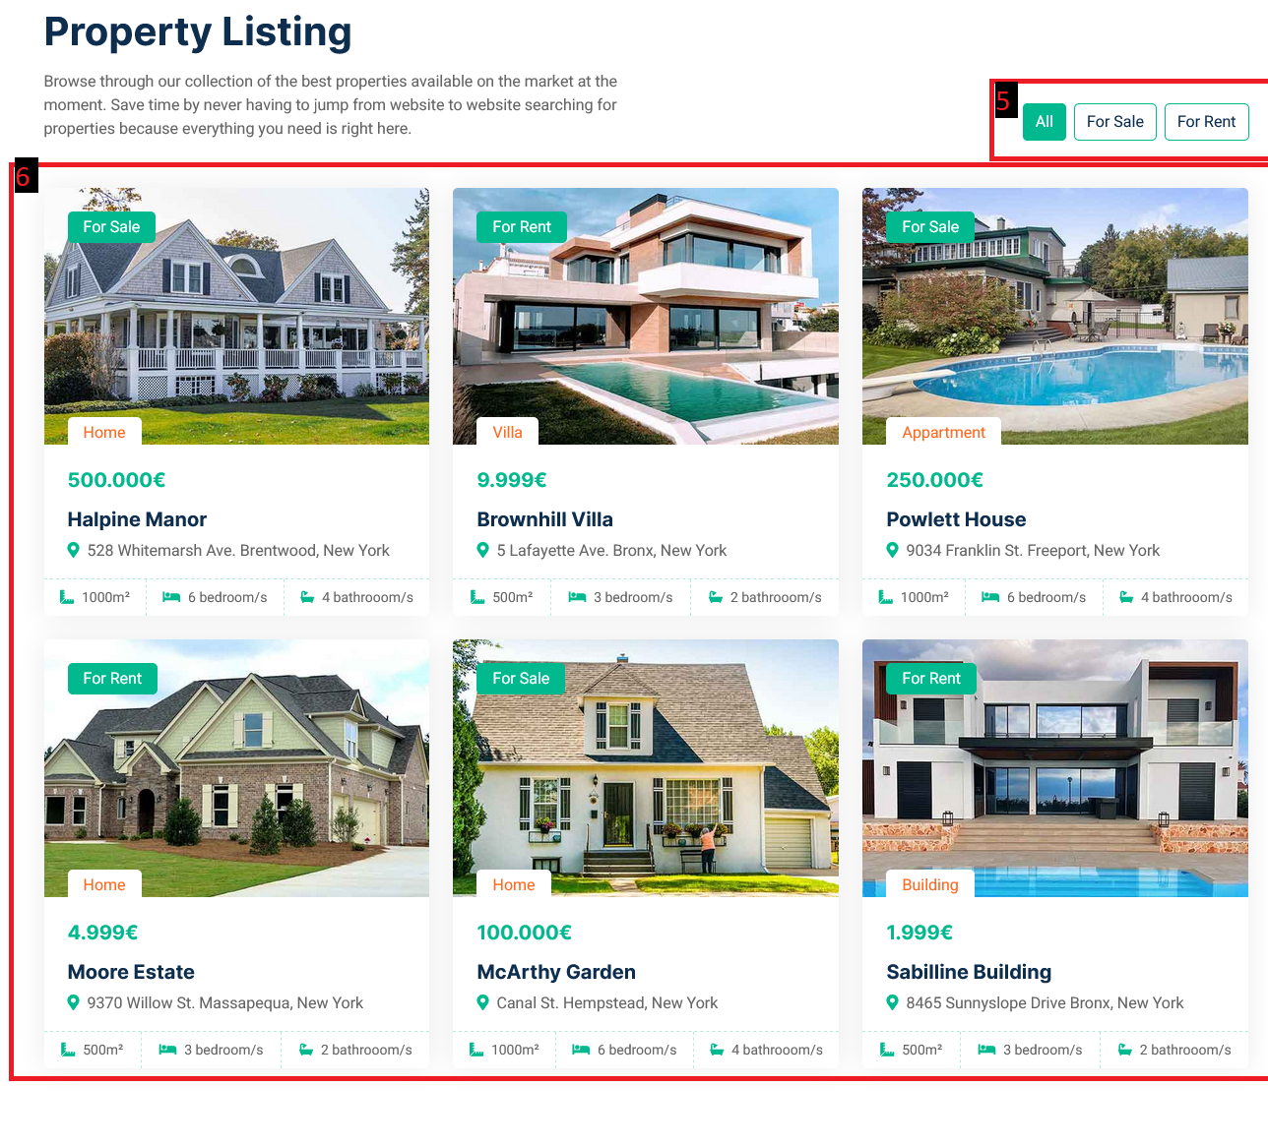

**5.**

* Opcije filtriranja elemenata unutar sekcije
* “All” – prikaz svih elemenata
* “For Sale” – prikaz samo onih elemenata sa oznakom “For Sale”, odnosno koji se prodaju
* “For Rent” – prikaz samo onih elemenata sa oznakom “For Rent”, odnosno koji se iznajmljuju

**6.**

* Dinamicki kreirani elementi zajedno sa svim sadrzajem koristeci dvodimenzionalni niz podataka
* Prelaskom preko bilo kog elementa, slika se zoom-ira



**7.**

* Klikom na taster “Read More” se dinamicki prikazuje dodatni paragraf pomocu .slideToggle(‘slow’)

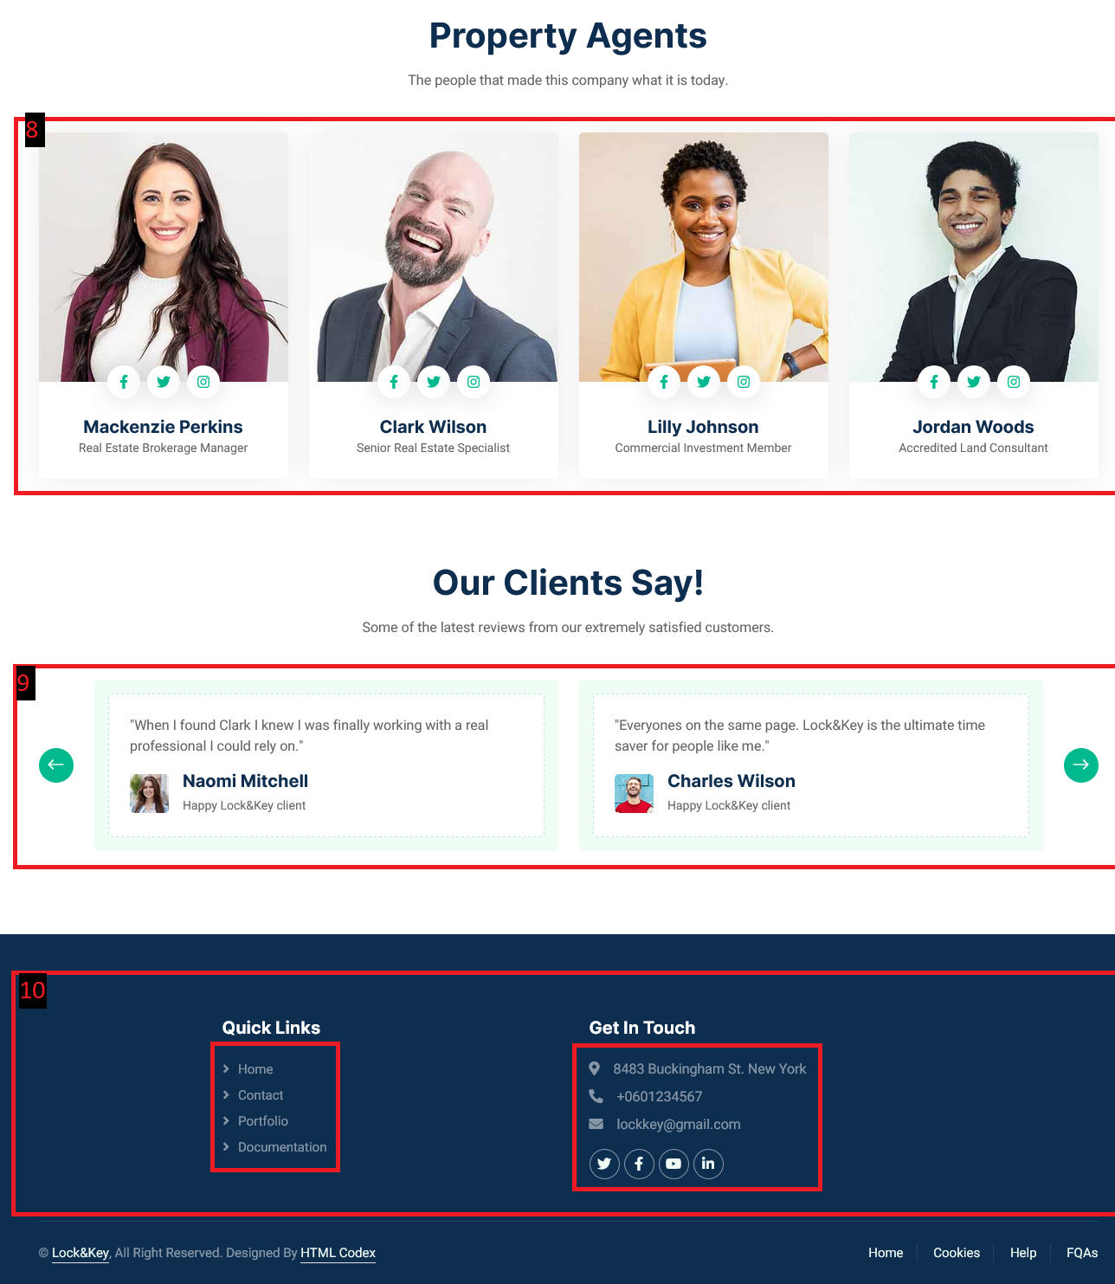

**8.**

* Elementi sekcije su dinamicki kreirani iz javascripta

**9.**

* Sadrzaj slider-a formiran kroz javascript iz matrice, a funkcionalnost pomocu Owl Carousel

**10.**

* Linkovi unutar “Quick Links” kreirani iz niza
* Sadrzaj unutar “Get in touch” zajedno sa ikonicama kreiran iz niza

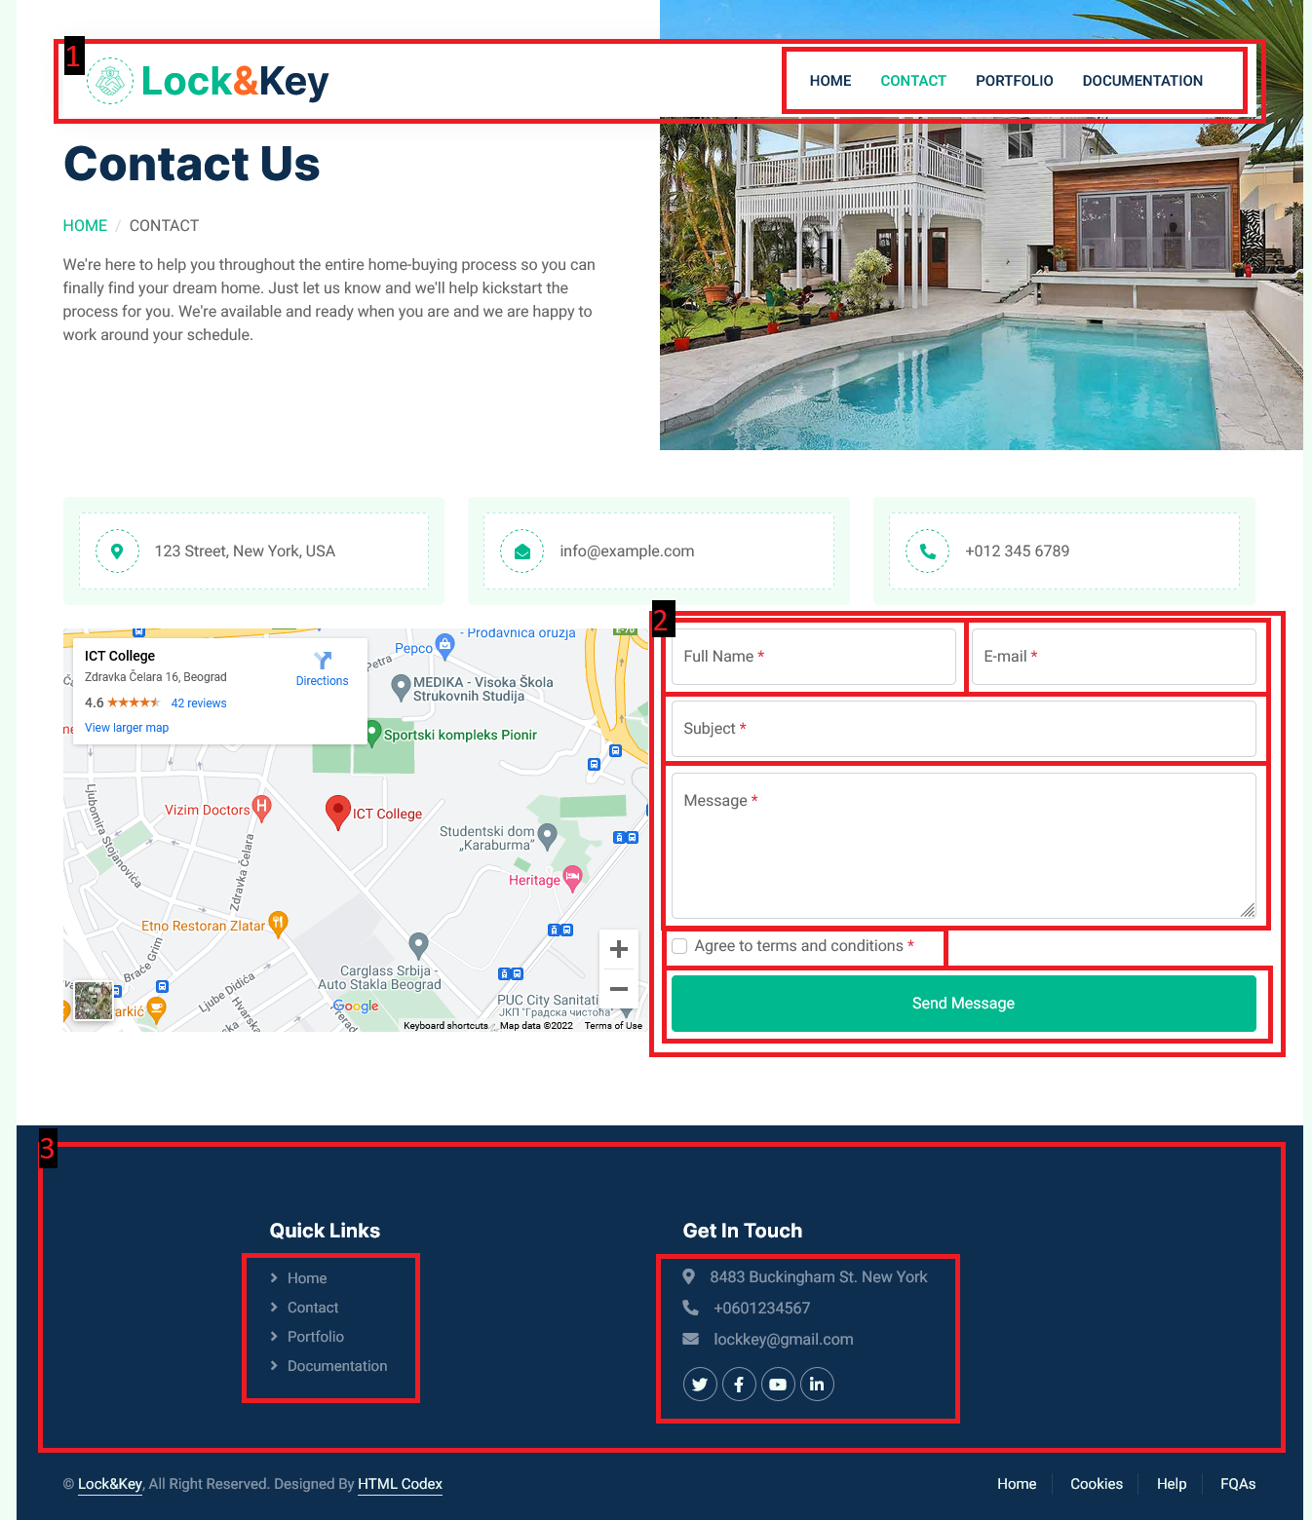

**1.**

* Dinamicko kreiranje linkova unutar navigacionog menija
* Dodeljivanje active klase ispitivanjem title taga

**2.**

* Klikom na taster “Send message” se poziva funkcija koja proverava ispravnost unetih podataka u svako polje forme
* Validacija forme pomocu regularnih izraza
* Ukoliko postoji greska prilikom unosa, svaki deo forme koji je pogresno popunjen dobije crvenu borduru i ima zaseban element odmah ispod polja, koje ce se prikazati i u kome ce biti ispisana greska, sta podrazumeva polje zajedno sa pravilnim primerom unosa
* Sva polja su obavezna zajedno sa checkbox-om
* Ukoliko ne postoji greska prilikom unosa, forma se resetuje, prikazuje se sakriveni element ispod forme sa porukom o uspesnom popunjavanju forme i poslatom porukom

**3.**

* Linkovi unutar “Quick Links” kreirani iz niza
* Sadrzaj unutar “Get in touch” zajedno sa ikonicama kreiran iz niza

# Kodovi

## HTML

### index.html

<!DOCTYPE html>

<html lang="en">

    <head>

        <meta charset="utf-8">

        <title>Lock&Key | Home</title>

        <meta content="width=device-width, initial-scale=1.0" name="viewport">

        <meta content="" name="keywords">

        <meta content="" name="description">

*<!-- Favicon -->*

        <link href="img/favicon.ico" rel="icon">

*<!-- Google Web Fonts -->*

        <link rel="preconnect" href="https://fonts.googleapis.com">

        <link rel="preconnect" href="https://fonts.gstatic.com" crossorigin>

        <link href="https://fonts.googleapis.com/css2?family=Heebo:wght@400;500;600&family=Inter:wght@700;800&display=swap" rel="stylesheet">

*<!-- MY CSS -->*

        <link href="assets/css/my-style.css" rel="stylesheet">

        <link href="https://cdn.jsdelivr.net/npm/bootstrap@5.2.3/dist/css/bootstrap.min.css" rel="stylesheet" integrity="sha384-rbsA2VBKQhggwzxH7pPCaAqO46MgnOM80zW1RWuH61DGLwZJEdK2Kadq2F9CUG65" crossorigin="anonymous">

*<!-- Icon Font Stylesheet -->*

        <link href="https://cdnjs.cloudflare.com/ajax/libs/font-awesome/5.10.0/css/all.min.css" rel="stylesheet">

        <link href="https://cdn.jsdelivr.net/npm/bootstrap-icons@1.4.1/font/bootstrap-icons.css" rel="stylesheet">

*<!-- Libraries Stylesheet -->*

        <link href="lib/animate/animate.min.css" rel="stylesheet">

        <link href="lib/owlcarousel/assets/owl.carousel.min.css" rel="stylesheet">

*<!-- Customized Bootstrap Stylesheet -->*

        <link href="css/bootstrap.min.css" rel="stylesheet">

*<!-- Template Stylesheet -->*

        <link href="css/style.css" rel="stylesheet">

    </head>

    <body>

        <div class="container-xxl bg-white p-0">

*<!-- Navbar Start -->*

            <div class="container-fluid nav-bar bg-transparent">

                <nav class="navbar navbar-expand-lg bg-white navbar-light py-0 px-4">

                    <a href="index.html" class="navbar-brand d-flex align-items-center text-center">

                        <div class="icon p-2 me-2">

                            <img class="img-fluid" src="img/icon-deal.png" alt="Icon" style="width: 30px; height: 30px;">

                        </div>

                        <h1 class="m-0 text-primary">Lock<span class="text-secondary">&</span><span class="text-dark">Key</span></h1>

                    </a>

                    <button type="button" class="navbar-toggler" data-bs-toggle="collapse" data-bs-target="#navbarCollapse">

                        <span class="navbar-toggler-icon"></span>

                    </button>

                    <div class="collapse navbar-collapse" id="navbarCollapse">

                    </div>

                </nav>

            </div>

*<!-- Navbar End -->*

*<!-- Header Start -->*

            <div class="container-fluid header bg-white p-0">

                <div class="row g-0 align-items-center flex-column-reverse flex-md-row">

                    <div class="col-md-6 p-5 mt-lg-5">

                        <h1 class="display-5 animated fadeIn mb-4"><span class="text-primary">Real Estate</span> service you won't find anywhere else.</h1>

                        <p class="animated fadeIn mb-4 pb-2">Top-ranked real estate agency in New York, offering the finest luxury homes and providing world class service</p>

                        <a href="#property-section" class="btn btn-primary py-3 px-5 me-3 animated fadeIn">Get Started</a>

                    </div>

                    <div class="col-md-6 animated fadeIn">

                        <div class="owl-carousel header-carousel">

                            <div class="owl-carousel-item">

                                <img class="img-fluid" src="img/carousel-1.jpg" alt="">

                            </div>

                            <div class="owl-carousel-item">

                                <img class="img-fluid" src="img/carousel-2.jpg" alt="">

                            </div>

                        </div>

                    </div>

                </div>

            </div>

*<!-- Header End -->*

*<!-- Search Start -->*

            <div class="container-fluid bg-primary mb-5 wow fadeIn" data-wow-delay="0.1s" style="padding: 35px;">

                <div class="container">

                    <div class="row g-2 justify-content-center">

                        <div class="col-md-8">

                            <div class="row g-3">

                                <div class="col-md-5 search-form-item">

                                </div>

                                <div class="col-md-5 search-form-item">

                                </div>

                            </div>

                        </div>

                        <div class="col-md-2">

                            <a id="search-btn" href="#search-btn" class="btn btn-dark border-0 w-100 py-3">Search</a>

                        </div>

                    </div>

                </div>

            </div>

*<!-- Search End -->*

*<!-- Property List Start -->*

            <div class="container-xxl py-5" id="property-section">

                <div class="container">

                    <div class="row g-0 gx-5 align-items-end">

                        <div class="col-lg-6">

                            <div class="text-start mx-auto mb-5 wow slideInLeft" data-wow-delay="0.1s">

                                <h1 class="mb-3">Property Listing</h1>

                                <p>Browse through our collection of the best properties available on the market at the moment. Save time by never having to jump from website to website searching for properties because everything you need is right here.</p>

                            </div>

                        </div>

                        <div class="col-lg-6 text-start text-lg-end wow slideInRight" data-wow-delay="0.1s">

                            <ul class="nav nav-pills d-inline-flex justify-content-end mb-5" id="property-filters">

                                <li class="nav-item me-2">

                                    <a class="btn btn-outline-primary active" data-bs-toggle="pill" href="#property-section-content">All</a>

                                </li>

                                <li class="nav-item me-2">

                                    <a class="btn btn-outline-primary" data-bs-toggle="pill" href="#property-section-content">For Sale</a>

                                </li>

                                <li class="nav-item me-0">

                                    <a class="btn btn-outline-primary" data-bs-toggle="pill" href="#property-section-content">For Rent</a>

                                </li>

                            </ul>

                        </div>

                    </div>

                    <div class="tab-content">

                        <div id="tab-1" class="tab-pane fade show p-0 active">

                            <div class="row g-4" id="property-section-content">

                                <p id="no-property" class="alert alert-info text-center h5 p-5 hide"><i class="bi bi-info-square h2"></i></br></br></p>

                            </div>

                        </div>

                    </div>

                </div>

            </div>

*<!-- Property List End -->*

*<!-- About Start -->*

            <div class="container-xxl py-5">

                <div class="container">

                    <div class="row g-5 align-items-center">

                        <div class="col-lg-6 wow fadeIn" data-wow-delay="0.1s">

                            <div class="about-img position-relative overflow-hidden p-5 pe-0">

                                <img class="img-fluid w-100" src="img/about.jpg">

                            </div>

                        </div>

                        <div class="col-lg-6 wow fadeIn" data-wow-delay="0.5s">

                            <h1 class="mb-4">Leading the Way Since 1911</h1>

                            <p class="mb-4">Lock&Key, the place to find the perfect property. Above all, we are passionate about delivering unparalleled experiences. From sales, rentals and new development to mortgages and title insurance, our agents are relentless advocates for our clients. Our team is the top in the industry—they have access to the best and most reliable information and education, allowing them to expertly advise at every stage.

                            <p id="read-more" class="mb-4">We are backed by over a century's worth of insights and expertise We represent owners and tenants of all sizes across all industries, our goal is to achieve your objectives more easily. As the most trusted brand with the largest global network, Lock&Key is a genuine home for agents. By helping agents to be exceptional at what they do, we are ensuring that our customers receive the best level of service.</p></p>

                            <button id="read-more-btn" class="btn btn-primary py-3 px-5 mt-3">Read More</button>

                        </div>

                    </div>

                </div>

            </div>

*<!-- About End -->*

*<!-- Call to Action Start -->*

            <div class="container-xxl py-5">

                <div class="container">

                    <div class="bg-light rounded p-3">

                        <div class="bg-white rounded p-4" style="border: 1px dashed rgba(0, 185, 142, .3)">

                            <div class="row g-5 align-items-center">

                                <div class="col-lg-6 wow fadeIn" data-wow-delay="0.1s">

                                    <img class="img-fluid rounded w-100" src="img/call-to-action.jpg" alt="">

                                </div>

                                <div class="col-lg-6 wow fadeIn" data-wow-delay="0.5s">

                                    <div class="mb-4">

                                        <h1 class="mb-3">Contact With Our Certified Agent</h1>

                                        <p>If you have any questions dont hesitate to contact one of our agents with through a phone call.</p>

                                    </div>

                                    <a href="tel:0601234567" class="btn btn-secondary py-3 px-4 me-2"><i class="fa fa-phone-alt me-2"></i>Make A Call</a>

                                </div>

                            </div>

                        </div>

                    </div>

                </div>

            </div>

*<!-- Call to Action End -->*

*<!-- Team Start -->*

            <div class="container-xxl py-5">

                <div class="container">

                    <div class="text-center mx-auto mb-5 wow fadeInUp" data-wow-delay="0.1s" style="max-width: 600px;">

                        <h1 class="mb-3">Property Agents</h1>

                        <p>The people that made this company what it is today.</p>

                    </div>

                    <div id="agent-section" class="row g-4">

                    </div>

                </div>

            </div>

*<!-- Team End -->*

*<!-- Testimonial Start -->*

            <div class="container-xxl py-5">

                <div class="container">

                    <div class="text-center mx-auto mb-5 wow fadeInUp" data-wow-delay="0.1s" style="max-width: 600px;">

                        <h1 class="mb-3">Our Clients Say!</h1>

                        <p>Some of the latest reviews from our extremely satisfied customers.</p>

                    </div>

                    <div id="testimonials" class="owl-carousel testimonial-carousel wow fadeInUp" data-wow-delay="0.1s">

                    </div>

                </div>

            </div>

*<!-- Testimonial End -->*

*<!-- Footer Start -->*

            <div class="container-fluid bg-dark text-white-50 footer pt-5 mt-5 wow fadeIn" data-wow-delay="0.1s">

                <div class="container py-5">

                    <div class="row g-5 justify-content-center">

                        <div id="footer-quick-link" class="col-md-4">

                            <h5 class="text-white mb-4">Quick Links</h5>

                        </div>

                        <div id="footer-info" class="col-md-4">

                            <h5 class="text-white mb-4">Get In Touch</h5>

                        </div>

                    </div>

                </div>

                <div class="container">

                    <div class="copyright">

                        <div class="row">

                            <div class="col-md-6 text-center text-md-start mb-3 mb-md-0">

                                &copy; <a class="border-bottom" href="index.html">Lock&Key</a>, All Right Reserved.

*<!--/*** This template is free as long as you keep the footer author’s credit link/attribution link/backlink. If you'd like to use the template without the footer author’s credit link/attribution link/backlink, you can purchase the Credit Removal License from "https://htmlcodex.com/credit-removal". Thank you for your support. ***/-->*

                                Designed By <a class="border-bottom" href="https://htmlcodex.com">HTML Codex</a>

                            </div>

                            <div class="col-md-6 text-center text-md-end">

                                <div class="footer-menu">

                                    <a href="index.html">Home</a>

                                    <a href="#">Cookies</a>

                                    <a href="#">Help</a>

                                    <a href="#">FQAs</a>

                                </div>

                            </div>

                        </div>

                    </div>

                </div>

            </div>

*<!-- Footer End -->*

*<!-- Back to Top -->*

            <a href="#" class="btn btn-lg btn-primary btn-lg-square back-to-top"><i class="bi bi-arrow-up"></i></a>

        </div>

*<!-- JavaScript Libraries -->*

        <script src="https://code.jquery.com/jquery-3.4.1.min.js"></script>

        <script src="https://cdn.jsdelivr.net/npm/bootstrap@5.0.0/dist/js/bootstrap.bundle.min.js"></script>

        <script src="lib/wow/wow.min.js"></script>

        <script src="lib/easing/easing.min.js"></script>

        <script src="lib/waypoints/waypoints.min.js"></script>

        <script src="lib/owlcarousel/owl.carousel.min.js"></script>

        <script src="assets/js/main.js"></script>

        <script src="assets/js/custom-jquery.js"></script>

        <script src="https://cdn.jsdelivr.net/npm/bootstrap@5.2.3/dist/js/bootstrap.bundle.min.js" integrity="sha384-kenU1KFdBIe4zVF0s0G1M5b4hcpxyD9F7jL+jjXkk+Q2h455rYXK/7HAuoJl+0I4" crossorigin="anonymous"></script>

*<!-- Template Javascript -->*

        <script src="js/template-main.js"></script>

    </body>

</html>

### contact.html

<!DOCTYPE html>

<html lang="en">

<head>

    <meta charset="utf-8">

    <title>Lock&Key | Contact</title>

    <meta content="width=device-width, initial-scale=1.0" name="viewport">

    <meta content="" name="keywords">

    <meta content="" name="description">

*<!-- Favicon -->*

    <link href="img/favicon.ico" rel="icon">

*<!-- Google Web Fonts -->*

    <link rel="preconnect" href="https://fonts.googleapis.com">

    <link rel="preconnect" href="https://fonts.gstatic.com" crossorigin>

    <link href="https://fonts.googleapis.com/css2?family=Heebo:wght@400;500;600&family=Inter:wght@700;800&display=swap" rel="stylesheet">

*<!-- MY CSS WITH BOOTSTRAP -->*

    <link href="assets/css/my-style.css" rel="stylesheet"/>

    <link href="https://cdn.jsdelivr.net/npm/bootstrap@5.2.3/dist/css/bootstrap.min.css" rel="stylesheet" integrity="sha384-rbsA2VBKQhggwzxH7pPCaAqO46MgnOM80zW1RWuH61DGLwZJEdK2Kadq2F9CUG65" crossorigin="anonymous"/>

*<!-- Icon Font Stylesheet -->*

    <link href="https://cdnjs.cloudflare.com/ajax/libs/font-awesome/5.10.0/css/all.min.css" rel="stylesheet">

    <link href="https://cdn.jsdelivr.net/npm/bootstrap-icons@1.4.1/font/bootstrap-icons.css" rel="stylesheet">

*<!-- Libraries Stylesheet -->*

    <link href="lib/animate/animate.min.css" rel="stylesheet">

    <link href="lib/owlcarousel/assets/owl.carousel.min.css" rel="stylesheet">

*<!-- Customized Bootstrap Stylesheet -->*

    <link href="css/bootstrap.min.css" rel="stylesheet">

*<!-- Template Stylesheet -->*

    <link href="css/style.css" rel="stylesheet">

</head>

<body>

    <div class="container-xxl bg-white p-0">

*<!-- Navbar Start -->*

        <div class="container-fluid nav-bar bg-transparent">

            <nav class="navbar navbar-expand-lg bg-white navbar-light py-0 px-4">

                <a href="index.html" class="navbar-brand d-flex align-items-center text-center">

                    <div class="icon p-2 me-2">

                        <img class="img-fluid" src="img/icon-deal.png" alt="Icon" style="width: 30px; height: 30px;">

                    </div>

                    <h1 class="m-0 text-primary">Lock<span class="text-secondary">&</span><span class="text-dark">Key</span></h1>

                </a>

                <button type="button" class="navbar-toggler" data-bs-toggle="collapse" data-bs-target="#navbarCollapse">

                    <span class="navbar-toggler-icon"></span>

                </button>

                <div class="collapse navbar-collapse" id="navbarCollapse">

                </div>

            </nav>

        </div>

*<!-- Navbar End -->*

*<!-- Header Start -->*

        <div class="container-fluid header bg-white p-0">

            <div class="row g-0 align-items-center flex-column-reverse flex-md-row">

                <div class="col-md-6 p-5 mt-lg-5">

                    <h1 class="display-5 animated fadeIn mb-4">Contact Us</h1>

                        <nav aria-label="breadcrumb animated fadeIn">

                            <ol class="breadcrumb text-uppercase">

                                <li class="breadcrumb-item"><a href="index.html">Home</a></li>

                                <li class="breadcrumb-item text-body active" aria-current="page">Contact</li>

                            </ol>

                        </nav>

                    <p>We're here to help you throughout the entire home-buying process so you can finally find your dream home.  Just let us know and we'll help kickstart the process for you. We're available and ready when you are and we are happy to work around your schedule.</p>

                </div>

                <div class="col-md-6 animated fadeIn">

                    <img class="img-fluid" src="img/header.jpg" alt="">

                </div>

            </div>

        </div>

*<!-- Header End -->*

*<!-- Contact Start -->*

        <div class="container-xxl py-5">

            <div class="container-fluid">

                <div class="row g-4">

                    <div class="col-12">

                        <div class="row gy-4">

                            <div class="col-md-6 col-lg-4 wow fadeIn" data-wow-delay="0.1s">

                                <div class="bg-light rounded p-3">

                                    <div class="d-flex align-items-center bg-white rounded p-3" style="border: 1px dashed rgba(0, 185, 142, .3)">

                                        <div class="icon me-3" style="width: 45px; height: 45px;">

                                            <i class="fa fa-map-marker-alt text-primary"></i>

                                        </div>

                                        <span>123 Street, New York, USA</span>

                                    </div>

                                </div>

                            </div>

                            <div class="col-md-6 col-lg-4 wow fadeIn" data-wow-delay="0.3s">

                                <div class="bg-light rounded p-3">

                                    <div class="d-flex align-items-center bg-white rounded p-3" style="border: 1px dashed rgba(0, 185, 142, .3)">

                                        <div class="icon me-3" style="width: 45px; height: 45px;">

                                            <i class="fa fa-envelope-open text-primary"></i>

                                        </div>

                                        <span>info@example.com</span>

                                    </div>

                                </div>

                            </div>

                            <div class="col-md-6 col-lg-4 wow fadeIn" data-wow-delay="0.5s">

                                <div class="bg-light rounded p-3">

                                    <div class="d-flex align-items-center bg-white rounded p-3" style="border: 1px dashed rgba(0, 185, 142, .3)">

                                        <div class="icon me-3" style="width: 45px; height: 45px;">

                                            <i class="fa fa-phone-alt text-primary"></i>

                                        </div>

                                        <span>+012 345 6789</span>

                                    </div>

                                </div>

                            </div>

                        </div>

                    </div>

                    <div class="col-md-6 wow fadeInUp" data-wow-delay="0.1s">

                        <iframe class="position-relative rounded w-100 h-100"

                        src="https://www.google.com/maps/embed?pb=!1m18!1m12!1m3!1d2830.3586717145054!2d20.482226115733457!3d44.81425718459493!2m3!1f0!2f0!3f0!3m2!1i1024!2i768!4f13.1!3m3!1m2!1s0x475a7a9609031735%3A0xc17ed71f59ac4725!2sICT%20College!5e0!3m2!1sen!2srs!4v1671078028178!5m2!1sen!2srs"

                            frameborder="0" style="min-height: 400px; border:0;" allowfullscreen="" aria-hidden="false"

                            tabindex="0"></iframe>

                    </div>

                    <div class="col-md-6">

                        <div class="wow fadeInUp" data-wow-delay="0.5s">

                            <form name="form-contact" id="form-contact">

                                <div class="row g-3">

                                    <div class="col-md-6">

                                        <div class="form-floating">

                                            <input type="text" class="form-control" id="form-name" placeholder="Your Full Name"/>

                                            <label for="form-name">Full Name<span class="text-danger ms-1">*</span></label>

                                        </div>

                                        <p class="error-message alert alert-danger mt-1 p-2 hide"></p>

                                    </div>

                                    <div class="col-md-6">

                                        <div class="form-floating">

                                            <input type="email" class="form-control" id="form-email" placeholder="Your Email"/>

                                            <label for="form-email">E-mail<span class="text-danger ms-1">*</span></label>

                                        </div>

                                        <p class="error-message alert alert-danger mt-1 p-2 hide"></p>

                                    </div>

                                    <div class="col-12">

                                        <div class="form-floating">

                                            <input type="text" class="form-control" id="form-subject" placeholder="Subject"/>

                                            <label for="form-subject">Subject<span class="text-danger ms-1">*</span></label>

                                        </div>

                                        <p class="error-message alert alert-danger mt-1 p-2 hide"></p>

                                    </div>

                                    <div class="col-12">

                                        <div class="form-floating">

                                            <textarea class="form-control" placeholder="Leave a message here" id="form-message" style="height: 150px"/></textarea>

                                            <label for="form-message">Message<span class="text-danger ms-1">*</span></label>

                                        </div>

                                        <p class="error-message alert alert-danger mt-1 p-2 hide"></p>

                                    </div>

                                    <div class="col-12">

                                        <div class="form-check">

                                            <input class="form-check-input" type="checkbox" id="form-terms-conditions"/>

                                            <label class="form-check-label" for="form-terms-conditions">Agree to terms and conditions<span class="text-danger ms-1">*</span></label>

                                        </div>

                                        <p class="error-message alert alert-danger mt-1 p-2 hide"></p>

                                    </div>

                                    <div class="col-12">

                                        <input type="button" id="form-btn" class="btn btn-primary w-100 py-3" value="Send Message"/>

                                    </div>

                                </div>

                                <p id="no-error-message" class="alert alert-success mt-2 p-2 text-center hide"></p>

                            </form>

                        </div>

                    </div>

                </div>

            </div>

        </div>

*<!-- Contact End -->*

*<!-- Footer Start -->*

        <div class="container-fluid bg-dark text-white-50 footer pt-5 mt-5 wow fadeIn" data-wow-delay="0.1s">

            <div class="container py-5">

                <div class="row g-5 justify-content-center">

                    <div id="footer-quick-link" class="col-md-4">

                        <h5 class="text-white mb-4">Quick Links</h5>

                    </div>

                    <div id="footer-info" class="col-md-4">

                        <h5 class="text-white mb-4">Get In Touch</h5>

                    </div>

                </div>

            </div>

            <div class="container">

                <div class="copyright">

                    <div class="row">

                        <div class="col-md-6 text-center text-md-start mb-3 mb-md-0">

                            &copy; <a class="border-bottom" href="index.html">Lock&Key</a>, All Right Reserved.

*<!--/*** This template is free as long as you keep the footer author’s credit link/attribution link/backlink. If you'd like to use the template without the footer author’s credit link/attribution link/backlink, you can purchase the Credit Removal License from "https://htmlcodex.com/credit-removal". Thank you for your support. ***/-->*

                            Designed By <a class="border-bottom" href="https://htmlcodex.com">HTML Codex</a>

                        </div>

                        <div class="col-md-6 text-center text-md-end">

                            <div class="footer-menu">

                                <a href="index.html">Home</a>

                                <a href="#">Cookies</a>

                                <a href="#">Help</a>

                                <a href="#">FQAs</a>

                            </div>

                        </div>

                    </div>

                </div>

            </div>

        </div>

*<!-- Footer End -->*

*<!-- Back to Top -->*

        <a href="#" class="btn btn-lg btn-primary btn-lg-square back-to-top"><i class="bi bi-arrow-up"></i></a>

    </div>

*<!-- JavaScript Libraries -->*

    <script src="https://code.jquery.com/jquery-3.4.1.min.js"></script>

    <script src="https://cdn.jsdelivr.net/npm/bootstrap@5.0.0/dist/js/bootstrap.bundle.min.js"></script>

    <script src="lib/wow/wow.min.js"></script>

    <script src="lib/easing/easing.min.js"></script>

    <script src="lib/waypoints/waypoints.min.js"></script>

    <script src="lib/owlcarousel/owl.carousel.min.js"></script>

    <script src="assets/js/main.js"></script>

    <script src="https://cdn.jsdelivr.net/npm/bootstrap@5.2.3/dist/js/bootstrap.bundle.min.js" integrity="sha384-kenU1KFdBIe4zVF0s0G1M5b4hcpxyD9F7jL+jjXkk+Q2h455rYXK/7HAuoJl+0I4" crossorigin="anonymous"></script>

*<!-- Template Javascript -->*

    <script src="js/template-main.js"></script>

</body>

</html>

## CSS

### my-style.css

.hide {

    display: none !important;

}

.error-message {

    font-size: 0.8rem;

}

### style.css - (template)

*/********** Template CSS **********/*

:root {

    --primary: #00B98E;

    --secondary: #FF6922;

    --light: #EFFDF5;

    --dark: #0E2E50;

}

.back-to-top {

    position: fixed;

    display: none;

    right: 45px;

    bottom: 45px;

    z-index: 99;

}

*/*** Spinner ***/*

#spinner {

    opacity: 0;

    visibility: hidden;

    transition: opacity .5s ease-out, visibility 0s linear .5s;

    z-index: 99999;

}

#spinner.show {

    transition: opacity .5s ease-out, visibility 0s linear 0s;

    visibility: visible;

    opacity: 1;

}

*/*** Button ***/*

.btn {

    transition: .5s;

}

.btn.btn-primary,

.btn.btn-secondary {

    color: #FFFFFF;

}

.btn-square {

    width: 38px;

    height: 38px;

}

.btn-sm-square {

    width: 32px;

    height: 32px;

}

.btn-lg-square {

    width: 48px;

    height: 48px;

}

.btn-square,

.btn-sm-square,

.btn-lg-square {

    padding: 0;

    display: flex;

    align-items: center;

    justify-content: center;

    font-weight: normal;

    border-radius: 50px;

}

*/*** Navbar ***/*

.nav-bar {

    position: relative;

    margin-top: 45px;

    padding: 0 3rem;

    transition: .5s;

    z-index: 9999;

}

.nav-bar.sticky-top {

    position: sticky;

    padding: 0;

    z-index: 9999;

}

.navbar {

    box-shadow: 0 0 30px rgba(0, 0, 0, .08);

}

.navbar .dropdown-toggle::after {

    border: none;

    content: "\f107";

    font-family: "Font Awesome 5 Free";

    font-weight: 900;

    vertical-align: middle;

    margin-left: 5px;

    transition: .5s;

}

.navbar .dropdown-toggle[aria-expanded=true]::after {

    transform: rotate(-180deg);

}

.navbar-light .navbar-nav .nav-link {

    margin-right: 30px;

    padding: 25px 0;

    color: #FFFFFF;

    font-size: 15px;

    text-transform: uppercase;

    outline: none;

}

.navbar-light .navbar-nav .nav-link:hover,

.navbar-light .navbar-nav .nav-link.active {

    color: var(--primary);

}

*@media* (max-width: 991.98px) {

    .nav-bar {

        margin: 0;

        padding: 0;

    }

    .navbar-light .navbar-nav .nav-link  {

        margin-right: 0;

        padding: 10px 0;

    }

    .navbar-light .navbar-nav {

        border-top: 1px solid #EEEEEE;

    }

}

.navbar-light .navbar-brand {

    height: 75px;

}

.navbar-light .navbar-nav .nav-link {

    color: var(--dark);

    font-weight: 500;

}

*@media* (min-width: 992px) {

    .navbar .nav-item .dropdown-menu {

        display: block;

        top: 100%;

        margin-top: 0;

        transform: rotateX(-75deg);

        transform-origin: 0% 0%;

        opacity: 0;

        visibility: hidden;

        transition: .5s;

    }

    .navbar .nav-item:hover .dropdown-menu {

        transform: rotateX(0deg);

        visibility: visible;

        transition: .5s;

        opacity: 1;

    }

}

*/*** Header ***/*

*@media* (min-width: 992px) {

    .header {

        margin-top: -120px;

    }

}

.header-carousel .owl-nav {

    position: absolute;

    top: 50%;

    left: -25px;

    transform: translateY(-50%);

    display: flex;

    flex-direction: column;

}

.header-carousel .owl-nav .owl-prev,

.header-carousel .owl-nav .owl-next {

    margin: 7px 0;

    width: 50px;

    height: 50px;

    display: flex;

    align-items: center;

    justify-content: center;

    color: #FFFFFF;

    background: var(--primary);

    border-radius: 40px;

    font-size: 20px;

    transition: .5s;

}

.header-carousel .owl-nav .owl-prev:hover,

.header-carousel .owl-nav .owl-next:hover {

    background: var(--dark);

}

*@media* (max-width: 768px) {

    .header-carousel .owl-nav {

        left: 25px;

    }

}

.breadcrumb-item + .breadcrumb-item::before {

    color: #DDDDDD;

}

*/*** Icon ***/*

.icon {

    padding: 15px;

    display: inline-flex;

    align-items: center;

    justify-content: center;

    background: #FFFFFF !important;

    border-radius: 50px;

    border: 1px dashed var(--primary) !important;

}

*/*** About ***/*

.about-img img {

    position: relative;

    z-index: 2;

}

.about-img::before {

    position: absolute;

    content: "";

    top: 0;

    left: -50%;

    width: 100%;

    height: 100%;

    background: var(--primary);

    transform: skew(20deg);

    z-index: 1;

}

*/*** Category ***/*

.cat-item div {

    background: #FFFFFF;

    border: 1px dashed rgba(0, 185, 142, .3);

    transition: .5s;

}

.cat-item:hover div {

    background: var(--primary);

    border-color: transparent;

}

.cat-item div * {

    transition: .5s;

}

.cat-item:hover div * {

    color: #FFFFFF !important;

}

*/*** Property List ***/*

.nav-pills .nav-item .btn {

    color: var(--dark);

}

.nav-pills .nav-item .btn:hover,

.nav-pills .nav-item .btn.active {

    color: #FFFFFF;

}

.property-item {

    box-shadow: 0 0 30px rgba(0, 0, 0, .08);

}

.property-item img {

    transition: .5s;

}

.property-item:hover img {

    transform: scale(1.1);

}

.property-item .border-top {

    border-top: 1px dashed rgba(0, 185, 142, .3) !important;

}

.property-item .border-end {

    border-right: 1px dashed rgba(0, 185, 142, .3) !important;

}

*/*** Team ***/*

.team-item {

    box-shadow: 0 0 30px rgba(0, 0, 0, .08);

    transition: .5s;

}

.team-item .btn {

    color: var(--primary);

    background: #FFFFFF;

    box-shadow: 0 0 30px rgba(0, 0, 0, .15);

}

.team-item .btn:hover {

    color: #FFFFFF;

    background: var(--primary);

}

.team-item:hover {

    border-color: var(--secondary) !important;

}

.team-item:hover .bg-primary {

    background: var(--secondary) !important;

}

.team-item:hover .bg-primary i {

    color: var(--secondary) !important;

}

*/*** Testimonial ***/*

.testimonial-carousel {

    padding-left: 1.5rem;

    padding-right: 1.5rem;

}

*@media* (min-width: 576px) {

    .testimonial-carousel {

        padding-left: 4rem;

        padding-right: 4rem;

    }

}

.testimonial-carousel .testimonial-item .border {

    border: 1px dashed rgba(0, 185, 142, .3) !important;

}

.testimonial-carousel .owl-nav {

    position: absolute;

    width: 100%;

    height: 40px;

    top: calc(50% - 20px);

    left: 0;

    display: flex;

    justify-content: space-between;

    z-index: 1;

}

.testimonial-carousel .owl-nav .owl-prev,

.testimonial-carousel .owl-nav .owl-next {

    position: relative;

    width: 40px;

    height: 40px;

    display: flex;

    align-items: center;

    justify-content: center;

    color: #FFFFFF;

    background: var(--primary);

    border-radius: 40px;

    font-size: 20px;

    transition: .5s;

}

.testimonial-carousel .owl-nav .owl-prev:hover,

.testimonial-carousel .owl-nav .owl-next:hover {

    background: var(--dark);

}

*/*** Footer ***/*

.footer .btn.btn-social {

    margin-right: 5px;

    width: 35px;

    height: 35px;

    display: flex;

    align-items: center;

    justify-content: center;

    color: var(--light);

    border: 1px solid rgba(255,255,255,0.5);

    border-radius: 35px;

    transition: .3s;

}

.footer .btn.btn-social:hover {

    color: var(--primary);

    border-color: var(--light);

}

.footer .btn.btn-link {

    display: block;

    margin-bottom: 5px;

    padding: 0;

    text-align: left;

    font-size: 15px;

    font-weight: normal;

    text-transform: capitalize;

    transition: .3s;

}

.footer .btn.btn-link::before {

    position: relative;

    content: "\f105";

    font-family: "Font Awesome 5 Free";

    font-weight: 900;

    margin-right: 10px;

}

.footer .btn.btn-link:hover {

    letter-spacing: 1px;

    box-shadow: none;

}

.footer .form-control {

    border-color: rgba(255,255,255,0.5);

}

.footer .copyright {

    padding: 25px 0;

    font-size: 15px;

    border-top: 1px solid rgba(256, 256, 256, .1);

}

.footer .copyright a {

    color: var(--light);

}

.footer .footer-menu a {

    margin-right: 15px;

    padding-right: 15px;

    border-right: 1px solid rgba(255, 255, 255, .1);

}

.footer .footer-menu a:last-child {

    margin-right: 0;

    padding-right: 0;

    border-right: none;

}

## JavaScript

### main.js

*if* (location.pathname == '/index.html') {

    var propertySection = document.getElementById('property-section-content');

    const contentPropertyMatrix = [

        ['For Sale', 'Home', '500.000', 'Halpine Manor', '528 Whitemarsh Ave. Brentwood, New York'],

        ['For Rent', 'Villa', '9.999', 'Brownhill Villa', '5 Lafayette Ave. Bronx, New York'],

        ['For Sale', 'Appartment', '250.000', 'Powlett House', '9034 Franklin St. Freeport, New York'],

        ['For Rent', 'Home', '4.999', 'Moore Estate', '9370 Willow St. Massapequa, New York'],

        ['For Sale', 'Home', '100.000', 'McArthy Garden', 'Canal St. Hempstead, New York'],

        ['For Rent', 'Building', '1.999', 'Sabilline Building ', '8465 Sunnyslope Drive Bronx, New York']

    ];

    const contentPropertyDetails = [[1000, 6, 4], [500, 3, 2], [1000, 6, 4], [500, 3, 2], [1000, 6, 4], [500, 3, 2]];

    const contentPropertyDivClasses = ['property-list-part col-lg-4 col-md-6', 'property-item rounded overflow-hidden', 'position-relative overflow-hidden', 'sale-or-rent bg-primary rounded text-white position-absolute start-0 top-0 m-4 py-1 px-3', 'bg-white rounded-top text-primary position-absolute start-0 bottom-0 mx-4 pt-1 px-3', 'p-4 pb-0', 'd-flex border-top'];

    const contentPropertyIconClasses = ['fa fa-ruler-combined text-primary me-2', 'fa fa-bed text-primary me-2', 'fa fa-bath text-primary me-2'];

*for* (let index = 0; index < 6; index++) {

*for*(let index = 1; index <= 7; index++) {

            window['propertyDiv' + index] = document.createElement('div');

            window['propertyDiv' + index].setAttribute('class', contentPropertyDivClasses[index-1]);

        }

        let propertyAnchor1 = document.createElement('a');

        propertyAnchor1.setAttribute('href', '#');

        let propertyImage = document.createElement('img');

        Object.assign(propertyImage, {

            className: 'img-fluid',

            src: `img/property-${index+1}.jpg`,

            alt: ''

        })

        let propertyHeader5 = document.createElement('h5');

        propertyHeader5.setAttribute('class', 'text-primary mb-3');

        let propertyAnchor2 = document.createElement('a');

        propertyAnchor2.setAttribute('class', 'd-block h5 mb-2');

        propertyAnchor2.setAttribute('href', '#');

        let propertyParagraph = document.createElement('p');

        let propertyIcon = document.createElement('i');

        propertyIcon.setAttribute('class', 'fa fa-map-marker-alt text-primary me-2');

*for* (let index = 1; index <= 3; index++) {

            window['propertySmall' + index] = document.createElement('small');

            window['propertySmall' + index].setAttribute('class', 'flex-fill text-center border-end py-2');

            window['propertyIcon' + index] = document.createElement('i');

            window['propertyIcon' + index].setAttribute('class', contentPropertyIconClasses[index - 1]);

            window['propertySmall' + index].appendChild(window['propertyIcon' + index]);

            propertyDiv7.appendChild(window['propertySmall' + index]);

        }

        propertyDiv5.classList.add('text-secondary');

        propertySmall2.classList.add('bedroom-num');

        propertySmall3.classList.remove('border-end');

        propertyDiv1.appendChild(propertyDiv2);

        propertyDiv2.appendChild(propertyDiv3);

            propertyDiv3.appendChild(propertyAnchor1);

                propertyAnchor1.appendChild(propertyImage);

            propertyDiv3.appendChild(propertyDiv4);

                propertyDiv4.textContent += contentPropertyMatrix[index][0];

            propertyDiv3.appendChild(propertyDiv5);

                propertyDiv5.textContent += contentPropertyMatrix[index][1];

        propertyDiv2.appendChild(propertyDiv6);

            propertyDiv6.appendChild(propertyHeader5);

                propertyHeader5.innerHTML += contentPropertyMatrix[index][2] + '&#x20AC;';

                propertyDiv6.appendChild(propertyAnchor2);

                    propertyAnchor2.innerHTML += contentPropertyMatrix[index][3];

                propertyDiv6.appendChild(propertyParagraph);

                    propertyParagraph.appendChild(propertyIcon);

                    propertyParagraph.innerHTML += contentPropertyMatrix[index][4];

        propertyDiv2.appendChild(propertyDiv7);

                propertySmall1.innerHTML += contentPropertyDetails[index][0] + 'm&#178;';

                propertySmall2.innerHTML += contentPropertyDetails[index][1] + ' bedroom/s';

                propertySmall3.innerHTML += contentPropertyDetails[index][2] + ' bathrooom/s';

    propertySection.append(propertyDiv1);

    }

*/* _*-*_ END|DYNAMIC "PROPERTY LISTING" CONTENT _*-*_ */*

*/* _*-*_ BEGIN|DYNAMIC "PROPERTY LISTING" FILTER _*-*_ */*

    var propertyFilters = document.querySelectorAll('#property-filters li a');

    var propertySaleOrRent = document.querySelectorAll('.sale-or-rent');

    var propertyListPart = document.querySelectorAll('.property-list-part');

*for* (const element of propertyFilters) {

        element.addEventListener('click', function() {

            document.querySelector('#property-filters li a.active').classList.remove('active');

            element.classList.add('active');

*for* (let index = 0; index < propertyListPart.length; index++) {

*if*((element.innerHTML != 'All') && !(element.innerHTML == propertySaleOrRent[index].innerHTML)) {

                    propertyListPart[index].classList.add('hide');

                }

*else* {

                    propertyListPart[index].classList.remove('hide');

                }

            }

        })

    }

*/* _*-*_ END|DYNAMIC "PROPERTY LISTING" FILTER _*-*_ */*

*/* _*-*_ BEGIN|DYNAMIC "SEARCH" CONTENT _*-*_ */*

    var searchFields = document.querySelectorAll(".search-form-item");

    var searchPropertySort = ['3 bedroom/s', '6 bedroom/s'];

    var searchPropertyTypes = ['Appartment', 'Building', 'Home', 'Villa'];

    var typeSelect = document.createElement('select');

    typeSelect.setAttribute('class', 'form-select border-0 py-3 search-form-ddl');

    typeSelect.setAttribute('id', 'search-type');

    searchFields[0].append(typeSelect);

    var typeDefaultOption = document.createElement('option');

    typeDefaultOption.setAttribute('value', 0);

    typeDefaultOption.innerHTML += 'Property Type...';

    typeSelect.append(typeDefaultOption);

*for* (let index = 0; index < searchPropertyTypes.length; index++) {

        let typeOption = document.createElement('option');

        typeOption.setAttribute('value', searchPropertyTypes[index]);

        typeOption.innerHTML += searchPropertyTypes[index];

        typeSelect.append(typeOption);

    }

    var sortSelect = document.createElement('select');

    sortSelect.setAttribute('class', 'form-select border-0 py-3 search-form-ddl');

    sortSelect.setAttribute('id', 'search-sort');

    searchFields[1].append(sortSelect);

    var sortDefaultOption = document.createElement('option');

    sortDefaultOption.setAttribute('value', 0);

    sortDefaultOption.innerHTML += 'Number of bedrooms...';

    sortSelect.append(sortDefaultOption);

*for* (let index = 0; index < searchPropertySort.length; index++) {

        let sortOption = document.createElement('option');

        sortOption.setAttribute('value', searchPropertySort[index]);

        sortOption.innerHTML += searchPropertySort[index];

        sortSelect.append(sortOption);

    }

    var searchFieldType = document.querySelector('#search-type');

    var searchFieldSort = document.querySelector('#search-sort');

    var searchFieldBtn = document.querySelector('#search-btn');

    var propertyBedroom = document.getElementsByClassName('bedroom-num');

    searchFieldBtn.addEventListener('click', function() {

*for* (let index = 0; index < propertyListPart.length; index++) {

            propertyListPart[index].classList.remove('hide');

*if* (!(searchFieldType.value == '0') && !(searchFieldSort.value == '0')) {

*if* ((!(searchFieldType.value == propertySaleOrRent[index].nextElementSibling.innerHTML)) || (!(searchFieldSort.value == propertyBedroom[index].textContent))) {

                    propertyListPart[index].classList.add('hide');

                }

            }

*else* *if* (!(searchFieldType.value == '0') && !(searchFieldType.value == propertySaleOrRent[index].nextElementSibling.innerHTML)) {

                propertyListPart[index].classList.add('hide');

            }

*else* *if* (!(searchFieldSort.value == '0') && !(searchFieldSort.value == propertyBedroom[index].textContent)) {

                propertyListPart[index].classList.add('hide');

            }

*else* {

                propertyListPart[index].classList.remove('hide');

            }

        }

*if* (propertySection.clientHeight == 0) {

            document.getElementById('no-property').classList.remove('hide');

            document.getElementById('no-property').innerHTML += 'There are no properties that match your search criteria!';

            document.getElementById('property-filters').parentElement.classList.add('hide');

        }

*else* {

            document.getElementById('no-property').classList.add('hide');

            document.getElementById('property-filters').parentElement.classList.remove('hide');

        }

    })

*/* _*-*_ END|DYNAMIC "SEARCH" CONTENT _*-*_ */*

*/* _*-*_ BEGIN|DYNAMIC "PROPERTY AGENTS" CONTENT _*-*_ */*

    var agentSection = document.getElementById('agent-section');

    const contentAgentDetails = [['Mackenzie Perkins', 'Real Estate Brokerage Manager'], ['Clark Wilson', 'Senior Real Estate Specialist'], ['Lilly Johnson', 'Commercial Investment Member'],['Jordan Woods', 'Accredited Land Consultant']];

    const contentAgentDivClasses = ['col-lg-3 col-md-6 wow fadeInUp', 'team-item rounded overflow-hidden', 'position-relative', 'position-absolute start-50 top-100 translate-middle d-flex align-items-center', 'text-center p-4 mt-3'];

    const contentAgentIconClasses = ['fab fa-facebook-f', 'fab fa-twitter', 'fab fa-instagram'];

*for* (let index = 0; index < 4; index++) {

*for* (let index = 1; index <= 5; index++) {

            window['agentDiv' + index] = document.createElement('div');

            window['agentDiv' + index].setAttribute('class', contentAgentDivClasses[index-1]);

        }

        let agentImage = document.createElement('img');

        Object.assign(agentImage, {

            className: 'img-fluid',

            src: `img/team-${index+1}.jpg`,

            alt: ''

        })

*for* (let index = 0; index < 3; index++) {

            window['agentAnchor' + index + 1] = document.createElement('a');

            window['agentAnchor' + index + 1].setAttribute('class', 'btn btn-square mx-1');

            window['agentIcon' + index + 1] = document.createElement('i');

            window['agentIcon' + index + 1].setAttribute('class', contentAgentIconClasses[index]);

            window['agentAnchor' + index + 1].appendChild(window['agentIcon' + index + 1]);

            agentDiv4.appendChild(window['agentAnchor' + index + 1]);

        }

        let agentHeader5 = document.createElement('h5');

        agentHeader5.setAttribute('class', 'fw-bold mb-0');

        let agentSmall = document.createElement('small');

        agentDiv1.appendChild(agentDiv2);

            agentDiv2.appendChild(agentDiv3);

                agentDiv3.appendChild(agentImage);

                agentDiv3.appendChild(agentDiv4);

            agentDiv2.appendChild(agentDiv5);

                agentDiv5.appendChild(agentHeader5);

                    agentHeader5.innerHTML += contentAgentDetails[index][0]

                agentDiv5.appendChild(agentSmall);

                    agentSmall.innerHTML += contentAgentDetails[index][1]

    agentSection.append(agentDiv1);

    }

*/* _*-*_ END|DYNAMIC "PROPERTY AGENTS" CONTENT _*-*_ */*

*/* _*-*_ BEGIN|DYNAMIC "TESTIMONIALS" CONTENT _*-*_ */*

    var testimonialsSection = document.getElementById('testimonials');

    const contentTestimonialsDetails = [

        ['"When I found Clark I knew I was finally working with a real professional I could rely on."' ,'Naomi Mitchell', 'Happy Lock&Key client'],

        ['"Everyones on the same page. Lock&Key is the ultimate time saver for people like me."' ,'Charles Wilson', 'Happy Lock&Key client'],

        ['"With Lock&Key, I have finally accomplished things that have been waiting forever to get done."' ,'Andrew Hill', 'Happy Lock&Key client']];

    const contentTestimonialsDivClasses = ['testimonial-item bg-light rounded p-3', 'bg-white border rounded p-4', 'd-flex align-items-center', 'ps-3'];

*for* (let index = 0; index < 3; index++) {

*for* (let index = 1; index <= 4; index++) {

            window['testimonialDiv' + index] = document.createElement('div');

            window['testimonialDiv' + index].setAttribute('class', contentTestimonialsDivClasses[index-1]);

        }

        let testimonialParagraph = document.createElement('p');

        let testimonialImage = document.createElement('img');

        Object.assign(testimonialImage, {

            className: 'img-fluid flex-shrink-0 rounded',

            src: `img/testimonial-${index+1}.jpg`,

            alt: ''

        });

        testimonialImage.style.width = '45px';

        testimonialImage.style.height = '45px';

        let testimonialHeader6 = document.createElement('h5');

        testimonialHeader6.setAttribute('class', 'fw-bold mb-1');

        let testimonialSmall = document.createElement('small');

        testimonialDiv1.appendChild(testimonialDiv2);

            testimonialDiv2.appendChild(testimonialParagraph);

                testimonialParagraph.innerHTML += contentTestimonialsDetails[index][0];

            testimonialDiv2.appendChild(testimonialDiv3);

                testimonialDiv3.appendChild(testimonialImage);

                testimonialDiv3.appendChild(testimonialDiv4);

                    testimonialDiv4.appendChild(testimonialHeader6);

                        testimonialHeader6.innerHTML += contentTestimonialsDetails[index][1];

                    testimonialDiv4.appendChild(testimonialSmall);

                    testimonialSmall.innerHTML += contentTestimonialsDetails[index][2];

    testimonialsSection.append(testimonialDiv1);

    }

*/* _*-*_ END|DYNAMIC "TESTIMONIALS" CONTENT _*-*_ */*

}

*else* *if* (location.pathname == '/contact.html') {

*/* _*-*_ BEGIN|CONTACT FORM VALIDATION _*-*_ */*

    var formSubmit = document.querySelector('#form-btn');

    formSubmit.addEventListener('click', formValidation);

    var errors = 0;

    function regExValidation(*formPart*, *regEx*, *errorMessage*) {

*if*(!*regEx*.test(*formPart*.value)) {

*formPart*.classList.add('border-2', 'border-danger', 'rounded');

*formPart*.parentElement.nextElementSibling.innerHTML = *errorMessage*;

*formPart*.parentElement.nextElementSibling.classList.remove('hide');

            errors++;

        }

*else*{

*formPart*.classList.remove('border-2', 'border-danger', 'rounded');

*formPart*.parentElement.nextElementSibling.innerHTML = '';

*formPart*.parentElement.nextElementSibling.classList.add('hide');

        }

    }

    function formValidation() {

        errors = 0;

        let formFullName, formEmail, formSubject, formMessage, formTerms, formSuccess;

        let regExFullName, regExEmail, regExSubject, regExMessage;

        formFullName = document.querySelector('#form-name');

        formEmail = document.querySelector('#form-email');

        formSubject = document.querySelector('#form-subject');

        formMessage = document.querySelector('#form-message');

        formTerms = document.querySelector('#form-terms-conditions');

        formSuccess = document.querySelector('#no-error-message');

        regExFullName = /*^*[A-ZČĆŠĐŽ][a-zčćđšž]{2,14}([\s][A-ZČĆŠĐŽ][a-zčćđšž]{2,14})+*$*/;

        regExEmail = /*^*[a-z0-9+_.-]+@[a-z0-9.-]+\.[a-z]{2,3}*$*/;

        regExSubject = /*^*[A-ZČĆŠĐŽa-zčćđšž0-9\s\.,!?""-]{3,}*$*/;

        regExMessage = /*^*.{10,}*$*/;

        regExValidation(formFullName, regExFullName, 'Field "Full name" accepts only letters. </br><em><small> - example: John Doe</small></em>');

        regExValidation(formEmail, regExEmail, 'Field "E-mail" is invalid. </br><em><small> - example: john.doe@gmail.com</small></em>');

        regExValidation(formSubject, regExSubject, 'Field "Subject" accepts letter, numbers and (!?.,-")');

        regExValidation(formMessage, regExMessage, 'Field "Message" must have at least 10 characters.');

*if*(!formTerms.checked) {

            formTerms.classList.add('border-2', 'border-danger', 'rounded');

            formTerms.nextElementSibling.classList.add('text-danger');

        }

*else* {

            formTerms.classList.remove('border-2', 'border-danger', 'rounded');

            formTerms.nextElementSibling.classList.remove('text-danger');

        }

*if*(errors==0) {

            formSuccess.classList.remove('hide');

            formSuccess.innerHTML = 'Thank you for contacting us. We will reply to your message ASAP!';

            document.getElementById("form-contact").reset();

*// document.getElementById("form-btn").removeAttribute('disabled');*

        }

    }

*/* _*-*_ END|CONTACT FORM VALIDATION _*-*_ */*

}

*/* _*-*_ BEGIN|DYNAMIC "NAVBAR" LINKS _*-*_ */*

var navPart = document.getElementById('navbarCollapse');

const navMatrix = [

    ['index.html', 'nav-item nav-link', 'Home'],

    ['contact.html', 'nav-item nav-link', 'Contact'],

    ['https://lthechubbyl.github.io/portfolio/', 'nav-item nav-link', 'Portfolio'],

    ['documentation.pdf', 'nav-item nav-link', 'Documentation']

];

let navDiv = document.createElement('div');

navDiv.setAttribute('class', 'navbar-nav ms-auto');

*for* (let index = 1; index <= 4; index++) {

    window['navAnchor' + index] = document.createElement('a');

    window['navAnchor' + index].setAttribute('href', navMatrix[index - 1][0])

    window['navAnchor' + index].setAttribute('class', navMatrix[index - 1][1]);

    window['navAnchor' + index].innerHTML += navMatrix[index - 1][2];

    navDiv.append(window['navAnchor' + index]);

}

navAnchor3.setAttribute('target', '_blank');

navPart.append(navDiv);

*/* - BEGIN|"NAVBAR" ACTIVE LINK - */*

*if* (document.title == 'Lock&Key | Home') {

    navAnchor1.classList.add('active');

}

*else* *if* (document.title == 'Lock&Key | Contact') {

    navAnchor2.classList.add('active');

}

*/* - END|"NAVBAR" ACTIVE LINK - */*

*/* _*-*_ END|DYNAMIC "NAVBAR" LINKS _*-*_ */*

*/* _*-*_ BEGIN|DYNAMIC "FOOTER" CONTENT _*-*_ */*

var footerQuickLink = document.getElementById('footer-quick-link');

const footerQuickLinkMatrix = [['Home', 'index.html'], ['Contact', 'contact.html'], ['Portfolio', 'https://lthechubbyl.github.io/portfolio/'], ['Documentation', 'documentation.pdf']];

var footerInfo = document.getElementById('footer-info');

const footerInfoMatrix = [

    ['fa fa-map-marker-alt me-3', '8483 Buckingham St. New York'],

    ['fa fa-phone-alt me-3', '+0601234567'],

    ['fa fa-envelope me-3', 'lockkey@gmail.com']

];

const footerIconPartArray = ['fab fa-twitter', 'fab fa-facebook-f', 'fab fa-youtube', 'fab fa-linkedin-in'];

*for* (let index = 0; index < footerQuickLinkMatrix.length; index++) {

    footerQuickLink.innerHTML += `<a class="btn btn-link text-white-50" href="${footerQuickLinkMatrix[index][1]}">${footerQuickLinkMatrix[index][0]}</a>`

}

*for* (let index = 0; index < footerInfoMatrix.length; index++) {

    footerInfo.innerHTML += `<p class="mb-2"><i class="${footerInfoMatrix[index][0]}"></i>${footerInfoMatrix[index][1]}</p>`

}

let footerInfoTemp = `<div class="d-flex pt-2">`;

*for* (let index = 0; index < footerIconPartArray.length; index++) {

    footerInfoTemp += `<a class="btn btn-outline-light btn-social" href="#"><i class="${footerIconPartArray[index]}"></i></a>`;

}

footerInfoTemp += `</div>`;

footerInfo.innerHTML += footerInfoTemp;

*/* _*-*_ END|DYNAMIC "FOOTER" CONTENT _*-*_ */*

### custom-jquery.js

$(document).ready(function(){

$('#read-more').hide();

    $('#read-more-btn').click(() => {

        $('#read-more').slideToggle('slow');

    })

});

### template-main.js - (template)

(function (*$*) {

    "use strict";

*// Spinner*

*// var spinner = function () {*

*//     setTimeout(function () {*

*//         if ($('#spinner').length > 0) {*

*//             $('#spinner').removeClass('show');*

*//         }*

*//     }, 1);*

*// };*

*// spinner();*

*// Initiate the wowjs*

    new WOW().init();

*// Sticky Navbar*

    $(window).scroll(function () {

*if* ($(this).scrollTop() > 45) {

            $('.nav-bar').addClass('sticky-top');

        } *else* {

            $('.nav-bar').removeClass('sticky-top');

        }

    });

*// Back to top button*

    $(window).scroll(function () {

*if* ($(this).scrollTop() > 300) {

            $('.back-to-top').fadeIn('slow');

        } *else* {

            $('.back-to-top').fadeOut('slow');

        }

    });

    $('.back-to-top').click(function () {

        $('html, body').animate({scrollTop: 0}, 1500, 'easeInOutExpo');

*return* false;

    });

*// Header carousel*

    $(".header-carousel").owlCarousel({

        autoplay: true,

        smartSpeed: 1500,

        items: 1,

        dots: true,

        loop: true,

        nav : true,

        navText : [

            '<i class="bi bi-chevron-left"></i>',

            '<i class="bi bi-chevron-right"></i>'

        ]

    });

*// Testimonials carousel*

    $(".testimonial-carousel").owlCarousel({

        autoplay: true,

        smartSpeed: 1000,

        margin: 24,

        dots: false,

        loop: true,

        nav : true,

        navText : [

            '<i class="bi bi-arrow-left"></i>',

            '<i class="bi bi-arrow-right"></i>'

        ],

        responsive: {

            0:{

                items:1

            },

            992:{

                items:2

            }

        }

    });

})(jQuery);